Maths Homework Autumn 1 Week 5
These robots love to make 10. Can you make 10 too?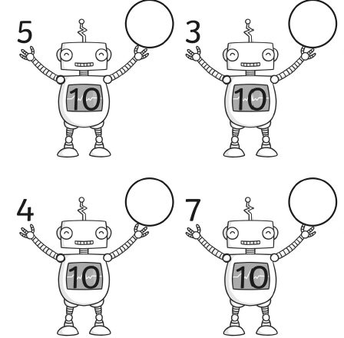
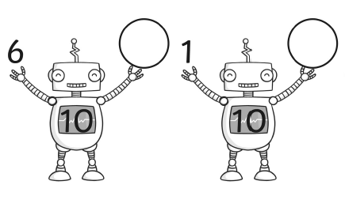
Learn Its!
We should instantly know the answer to these learn its. Have you learnt it? How fast can you answer them?
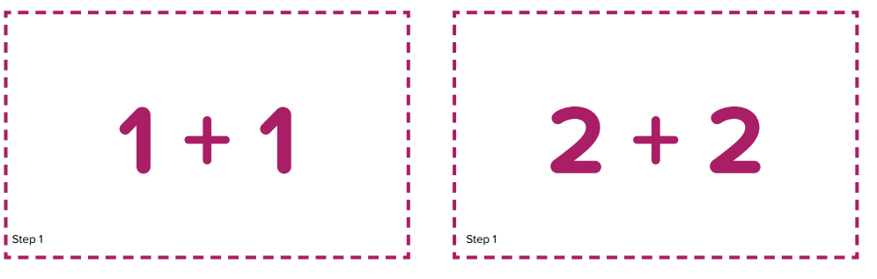
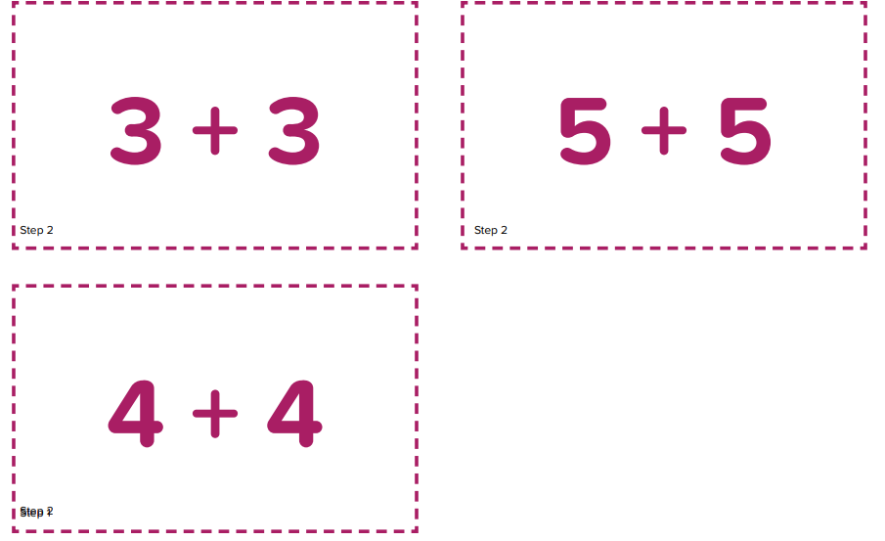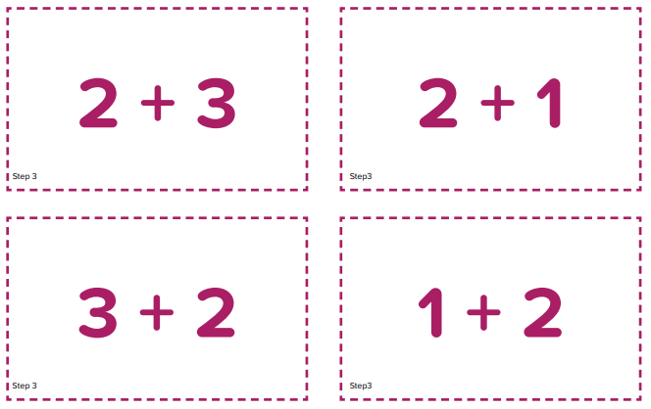

5

