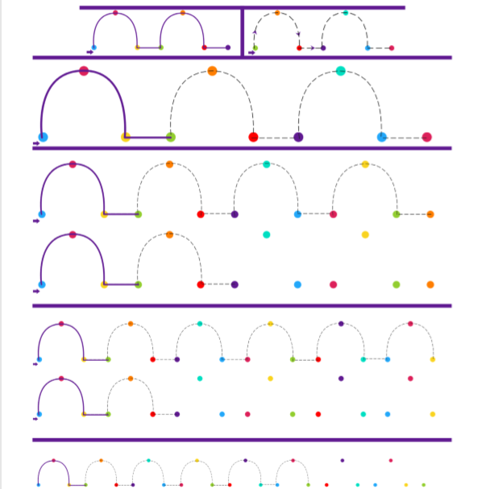
Can you do your own?
_________________________
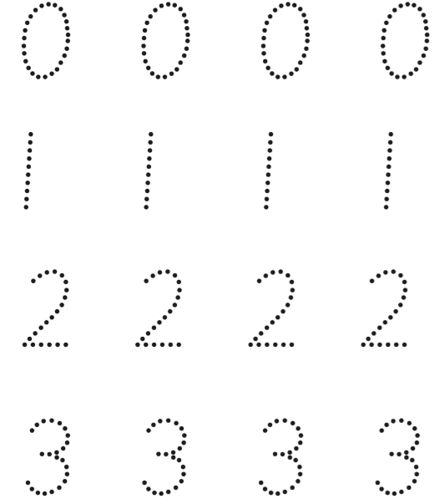
Practise your own now:
0_______________________
1_______________________
2_______________________3_______________________

