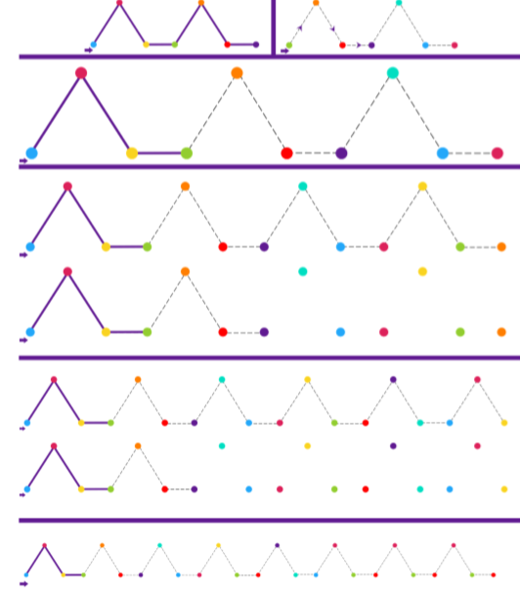

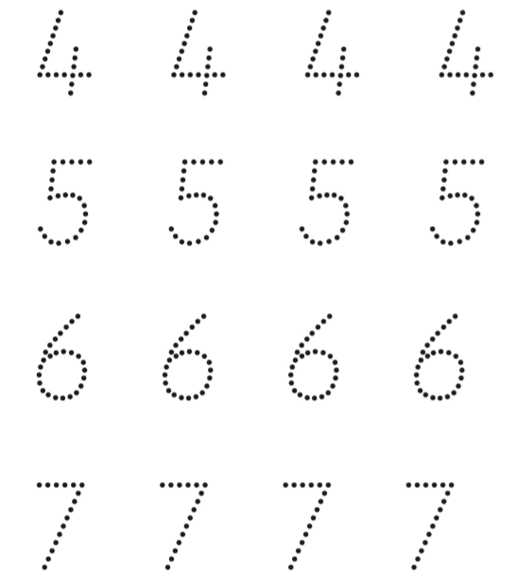
Try your own:
4_______________________________
5_______________________________
6_______________________________
7_______________________________

