Walkley Key Stage 1 Spelling Contract
5 points | 10 points | 20 points
Rainbow Words | Pyramid Writing | Consonant Circle
First write each word in pencil. Then trace over each word three times. Each time you trace, you must use a DIFFERENT colour crayon. Trace neatly and you will see a rainbow! | “Pyramid write” your spelling words.  You must write neatly!  home: h  ho  hom  home | Write each of your spelling words.  Then go back and circle all of the consonants in your words!  Don’t forget to write neatly!
Upper and Lower Case | Surround Words | Adding my words
Write your spelling words two times each.  First, write each word in UPPERCASE letters. Second, write each word in lower case letters.  SLIDE slide | Write your words on squared paper. Write “middle” letters, one letter in each box. Use two boxes for “tall” letters like t and l and “low” letters like j and g. Then outline the words using different colours. | Each letter has a value.  *Consonants are worth 10.  *Vowels are worth 5.  Write your spelling words. Then add up the value of each spelling word.  Example-  said = s a i d  10 + 5 + 5 + 10 = 30
Look, Cover, Write | ABC Order | Practice Test
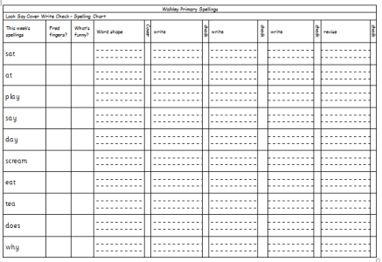  Fill in neatly all the boxes in the sheet. | First write you spelling words in a list.  Then write them in ABC order. | Take a practice test. Have your Mom or Dad ask you to spell your spelling words. Write them on a list. Check your practice test and correct any missed words.  This would be an especially good activity to complete on  Thursday night.
Backwards Words | Type Them | Magazine Words
Write your spelling words forwards and then backwards. Write neatly!  where erehw | Type your spelling words on the computer. Make each word have a different font. Print them out or show your parent. | Use an old magazine and find your words (or the letters that make up your word).  Cut them out and glue onto paper.
Spellings are taught on a Monday and tested on a Friday. Can you score 20 points to help us gain class wide rewards?

The Spelling Contract – Explained!
What is a spelling points contract?  Spelling contracts are a valuable tool to help motivate our children to learn their spelling words. A spelling contract gives children a sense of independence by allowing them to make decisions about how they would like to learn. Spelling contracts encourage children to commit to a certain amount of learning time, but they feature a variety of activities that children can choose to complete. A child who loves to write can make up a story with his or her spelling words, while an artistic child can choose to make a spelling word collage with pictures cut from his or her favourite magazines. If a child prefers the ‘read, write, cover, check’ approach to learning spellings then that is accepted too. The contract is also designed for pupils to take responsibility for their own academic success. This is a skill that will benefit them for the rest of their lives.  How does it work?  Spellings will be given out on Monday evening. Each child will be given a spelling contract containing a list of activities that relate to a points system. They must choose activities to complete each week to practice their given words and reach their points target. To begin with, we will give children a target of 20 points. Children can achieve their 20 points by selecting activities from the contract. (For example, they could complete four of the 5 point activities, two of the 10 point activities, or one worth 10 points and two worth 5 points.) Children should bring evidence of their activities into school every Friday morning and should be encouraged to try a variety of activities during the term. | What should I do if I lose my spelling contract or my word list?  The spelling contract will always be available to download on the school blog and there will also be spare copies in the classroom.  How much time should I spend completing spelling tasks?  The contract is designed so that you can spread activities over the week. This will break up the activities into smaller chunks and revisiting spellings regularly is the best way to learn them. The contract will not have an impact if you rush the work the night before homework is due.  Rewards  The value of each activity must add up to the number of points needed for the week in order to receive a token for doing spelling homework.  - 10 bronze tokens will earn a bronze certificate,  - 10 silver tokens leading to a silver certificate  - 10 gold tokens leading to a gold certificate  If you have any further questions please call in at the end of the day.  Key Stage One

