Reading timer
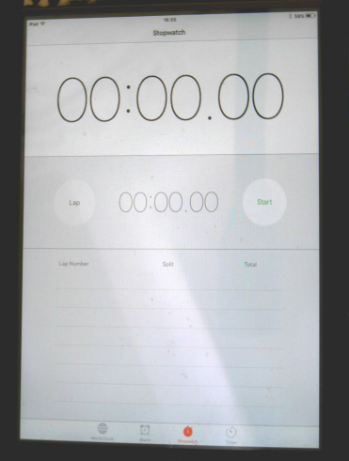
too room cool sloo stoo goop goof pool roof quoop droog zoo phoom food zoom bood boot snoop moon soon oon shoop boom voopop hoof shoodad whoop toobem floove

