-ing openers  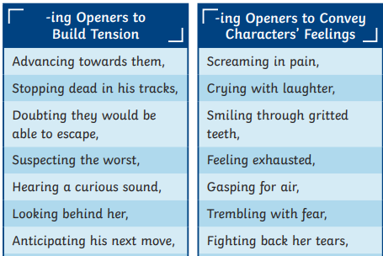 | Conjunctions  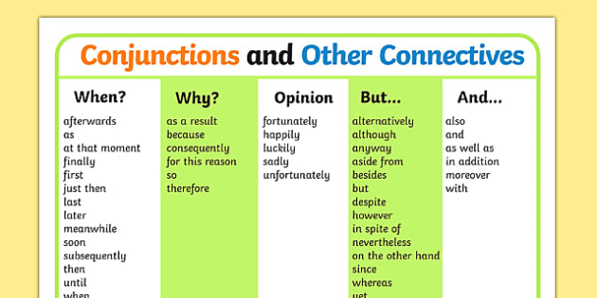
Prepositional phrases  Beside the…. Beneath the……  Through the……. Between the…..  Surrounded by….. | Treasure vocabulary  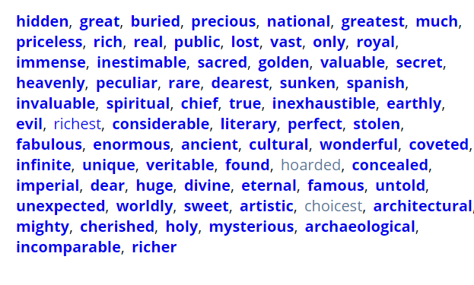
Relative clauses
who which
Lara, who was lying on her bed, listened to her parents arguing.
The treasure chest, which glinted in the sunlight, was bursting with gold.

