
Adapted to its environment in many ways.
- Large chest as they have large lungs to submerge for days at a time
- Hump and top of the head are visible above water
- Long arms to quickly grab prey
- Large webbed feet which makes it an efficient hunter
4. Diet
3. Appearance
- Mostly piscivore (eats fish and seafood)
- Varies depending on the season.
- Winter months it can also hunt for small mammals on shore
- Summer months it eats solely fish and seafood
- Can stalk it’s prey for several hours
- Been known to eat humans when food supply is very short

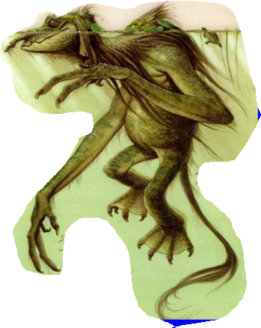
5. Warnings and Advice
- Always exercise caution near rivers in North America
- Be particularly wary in the winter months and at night-time.
- If you see one, run inland (away from any body of water) quickly
- North America
- Dwell in rivers and don’t travel far from water
- Rarely seen on land
- Many humans don’t encounter them
Summer – they migrate into depths of water to escape sunlight
Do you wonder why River Trolls are rarely seen?
- Nocturnal as sunlight turns them into stone.
2. Habitat
- HOOK

