L/O: to present my report using narrations on Powerpoint | What I think | My teacher thinks
I can remember to:
Add photos on my slides which match my report e.g. direct sunlight – a photo of the sun! | 〇
Click on Slideshow tab and then Record Slideshow  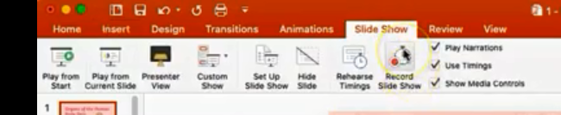 | 〇
Speak in a loud and clear voice | 〇
Match up the photos on the slide to the correct part of your report | 〇

