L/O: to be able to identify key features of a playscript. | What I think | My teacher thinks
I can remember to:
Read the playscript. | 〇
Read the PowerPoint about the features. | 〇
Label the playscripts with the features. | 〇
Complete the checklist. | 〇

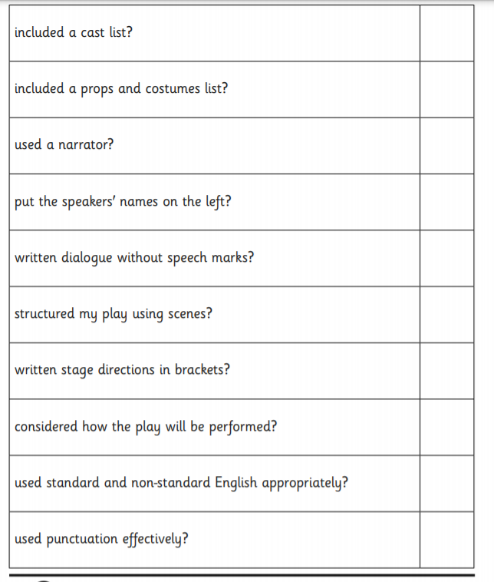
Monday 1st March 2021

