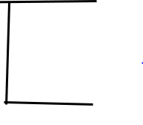
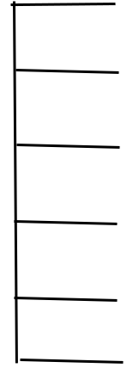
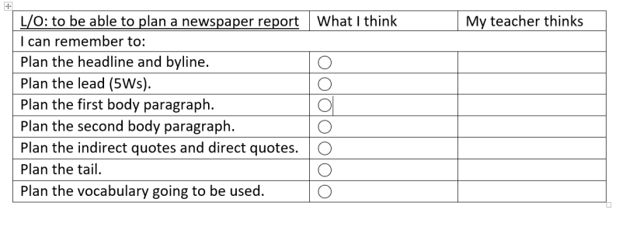
- 3 vaccines have now been approved
- Huge vaccination program starting – first to be vaccinated are most vulnerable
- Cases in England rising sharply
- New strain of virus which is reportedly 50-70% more transmissible
- 4th January = 26,626 Covid patients in hospital in England (up 30% on a week earlier)
- Strain on NHS services and shortage of beds in hospitals
- Hospital admissions up 40% compared to the first lockdown
- 80,664 positive tests on 29 December (three times higher than at the start of December)
Schools
- Decision to close schools came days after the NEU (the largest education union) urged teachers not to go into school (unless teaching key and vulnerable children) as it was not safe.
- Schools to close to prevent further spread of virus

DIRECT SPEECH – Bob Smith (doctor) “NHS is under a lot of strain.”
INDIRECT SPEECH – Went on to say that without further intervension, would have become overwhelmed.

DIRECT SPEECH – Boris Johnson – weeks ahead, “will be the hardest yet.”
INDIRECT SPEECH – Gavin Williamson (education secretary) – disappointed schools will need to close.
DIRECT SPEECH – Boris Johnson – “I completely understand the inconvenience and distress this late change will cause millions of parents and pupils up and down the country.”
INDIRECT SPEECH – Local hairdresser – this decision is devastating for his business.

Lead – 5 W’s
- Must stay at home at all times, if at all possible.
- Can go to work if you can’t work from home
- Can shop for necessities such as food and to exercise once a day (in local area)
- Can still meet childcare/support bubble if necessary.
Closed
- Non-essential shops need to be closed
- Hospitality venues to shut (open for takeaways still)
- Leisure, sports and entertainment facilities closed
- Overnight accommodation closed (hotels)
Schools
- Schools must close immediately (apart from key worker and vulnerable children.
- U-turn as the day before, Johnson urged parents to send children into school.
- Millions of children went back to school for one day after holidays. Exams also cancelled.

What was announced?
Why was the decision taken?
Who – Boris Johnson. Will affect schools and non-essential retail
What – announced lock down
-Must stay at home wherever possible
- Schools closing for the majority of pupils
When – Comes into effect at 00:01 on January 6th . To last at least 6 weeks.
Where – All of England. Other parts of the UK are also facing a similar lockdown
Why -
A NEW YEAR, A NEW LOCKDOWN
England to enter a third lockdown due to Coronovirus
By K Hall (Politics editor)
Headline and by-line
Tail

