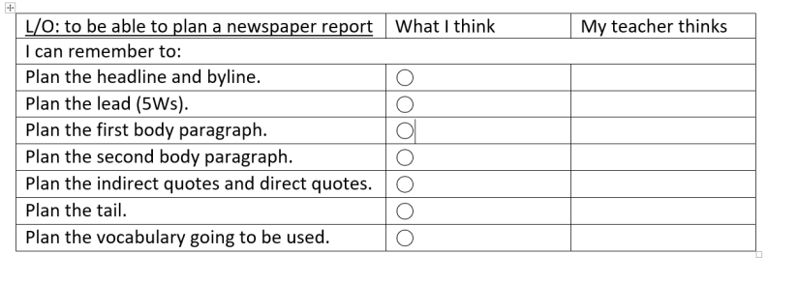


DIRECT SPEECH –
INDIRECT -
DIRECT SPEECH –
INDIRECT -
DIRECT SPEECH –
INDIRECT -
Why was the decision taken?
What was announced?
Lead – 5 W’sa
Headline and by-line
Tail

