Synonyms for said  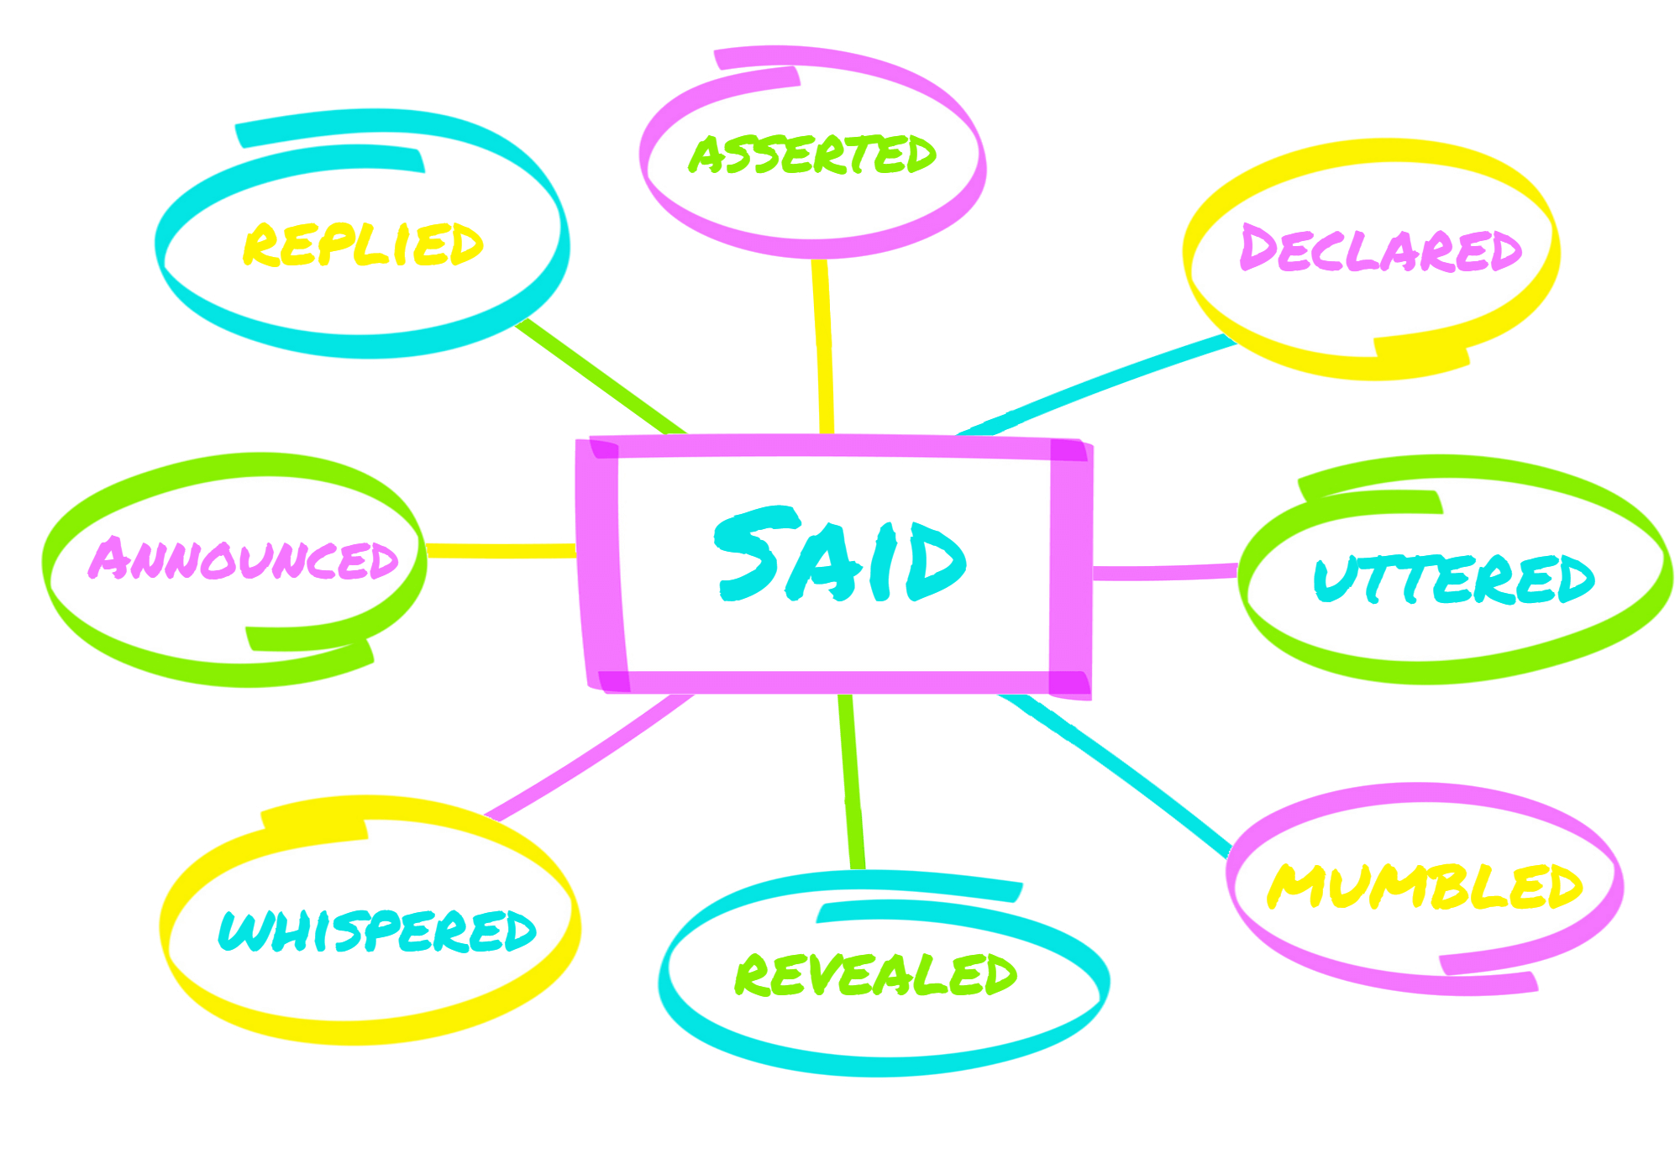 | Conjunctions  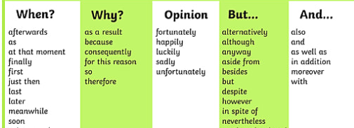  Differing viewpoint conjunctions are found in the But… section
Indirect quotes sentence starters  - He reported that . . .  - He also claimed that . . .  - She went on to state that . . .  - He confirmed that . . .  - She claimed that . . .  - She went on to tell us that . . . | Formal vocabulary  transmission vulnerable restrictions  vaccine measures essential  nationwide crackdown nation  exceed admissions coronavirus  urgent remote amid
Relative clauses  who which  Boris Johnson, who was addressing the nation from Downing Street, stated the restrictions will last at least seven weeks.  The restrictions, which come into effect at 00:01 on January 6th, are the toughest the nation has seen since April. | General sentences starters  Under the….  According to….  Details have emerged…  A number of reports suggest….  Despite announcing….

