5TH JANUARY 2021 | NEWS TODAY  Latest news and bulletin updates |  |  | Issue  #10
E W  England is in lockdown…AGAIN  The latest updates  Yesterday at 8pm Boris Johnson (British prime minister) declares a National lockdown, tis lockdown would affect many businesses and people finically, many people suspected a lockdown was going to happen so when Johnson announced the news of the lockdown it was not that big of a shock to anyone. The big message the government are trying to spread is Stay At Home, all schools would be closed to most pupils unless your parent is a keyworker, then school is still open for you to access. January 6th 00:01the lockdown will set in place. Boris Johnson stated that, “All schools will remain closed until at least February half term.”  Boris Johnson announced a national lockdown where you can only leave the house for essential purposes, such as exercise once a day (in a local area), shopping for food and medication. You can also go to work if you cannot work from home. Non-essential shops will close along with restaurants (takeaway is still accessible.) 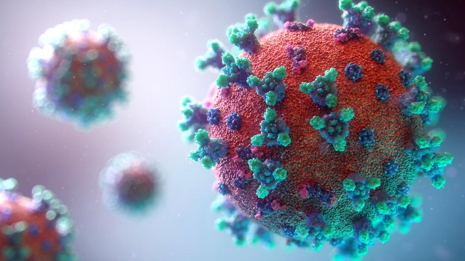 |  |  | 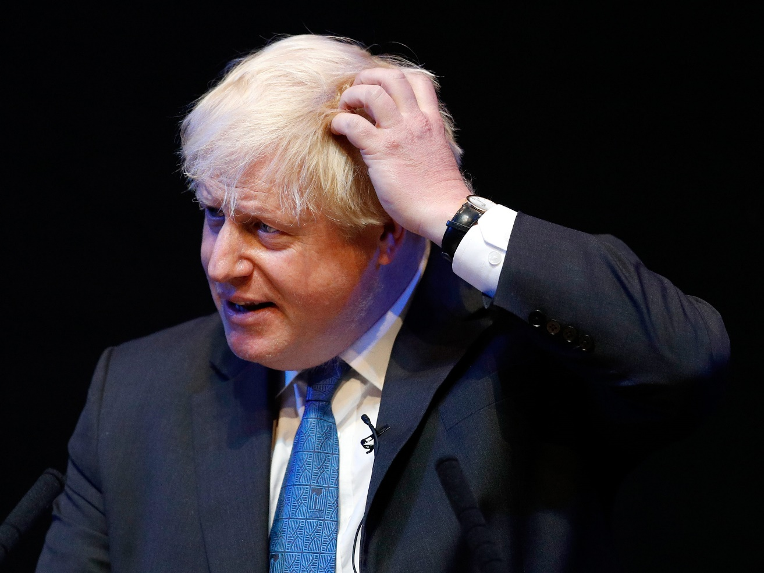
 |  |  | Boris Johnson makinng a tough decsion.
E W

The decision of lockdown was made because many people were not following Government guidelines. The new strain of COvID-19 is 50-70 % more transmissible. On January 4th there were 26,626 COVID Patients in hospital. The Doctor stated that if something is not done the NHS will start to Get overwhelmed.

Britain have officially started the mass roll out system
And have three approved vaccines. We asked Laura one off the
People walking by how they felt about the vaccines being
Given out to people and SHE STATED “I’m very pleased that
We have vaccines in the country because they will help slow
Down the pace of COVID19 cases and will make sure it does not spread.

