4 | Science – The circulatory system | What I  think | My teacher thinks
LO: To label the parts of the lungs and describe their function
I can remember to:
Label each part correctly
Describe the function of the alveoli
Describe how oxygen dissolves into the capillaries
Describe how CO² is a waste product
ACTIVITY 1 – Label the diagram below
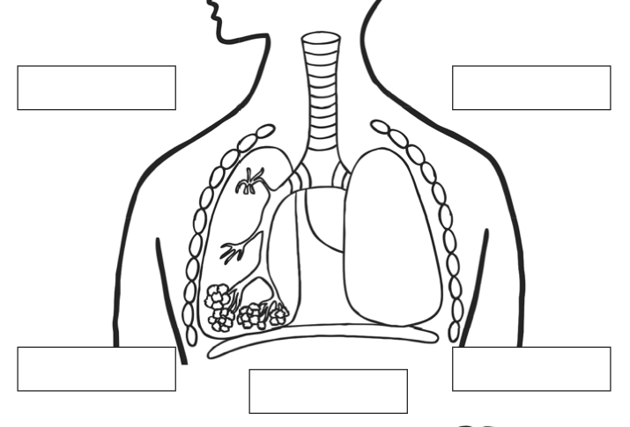
4)

5)
1)

trachea

bronchus

diaphragm

bronchiole

alveoli
4)
2)
3)

CHALLENGE – Watch the following video, then fill in the blanks below.
https://www.youtube.com/watch?v=3uFsUBY3Whs&feature=emb_logo

Alveoli are surrounded by a network of blood vessels called ______________. When we breathe in, there is more oxgygen in the _____________ then in the ___________ . Diffusion then happens as gases always move from an area of ________ concentration to an area of low concentration. Oxygen molecules then dissolve along the thin membrane of the alveolus into the ___________ vessels. This oxygenated blood then returns to the ____________. Carbon dioxide (a waste product) then moves from the blood into the _____________.

