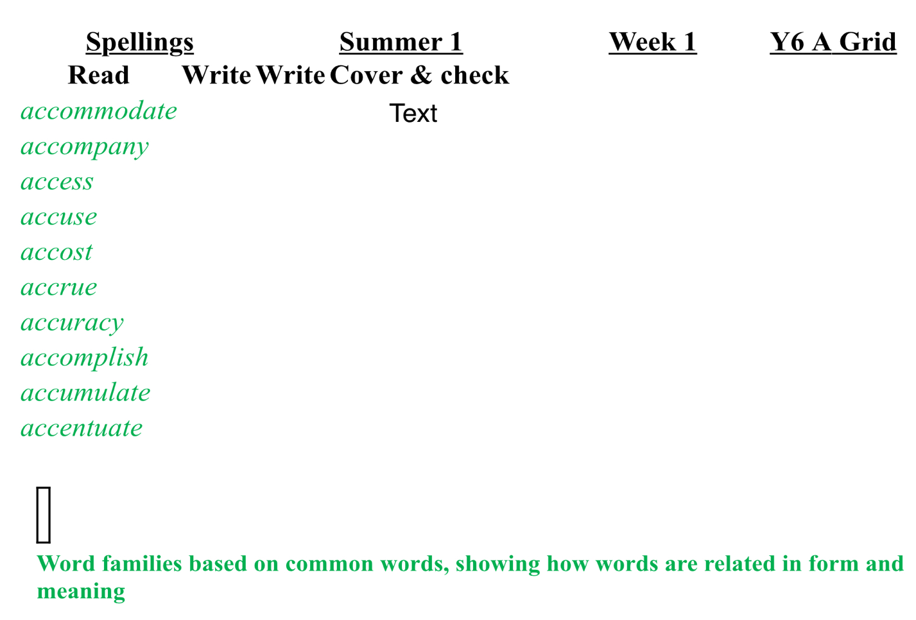
Accommodate. Accommodate Accommodate
Accompany. Accompany. Accompany
Access. Access. Access
Accuse. Accuse. Accuse
Accost. Accost. Accost
Accrue. Accrue. Accrue
Accuracy. Accuracy. Accuracy
Accomplish. Accomplish. Accomplish
Accumulate. Accumulate Accumulate
Accentuate. Accentuate. Accentuate

