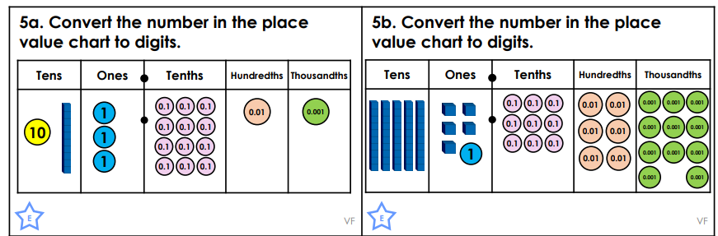
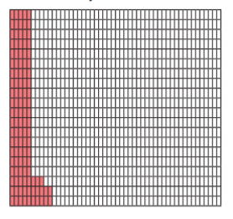
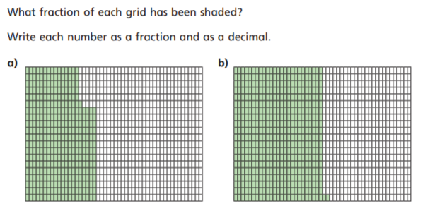
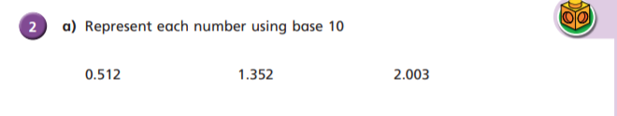
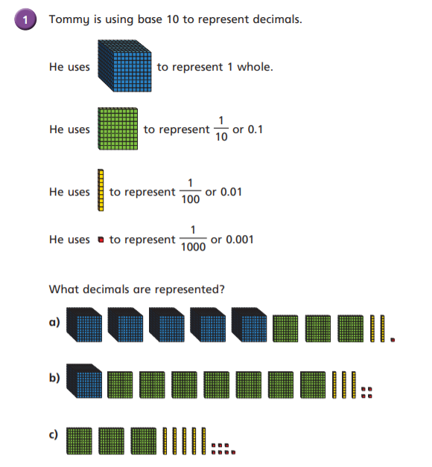
LEVEL 2 FLUENCY – TUESDAY
Draw each number as place value counters in a place value chart.

