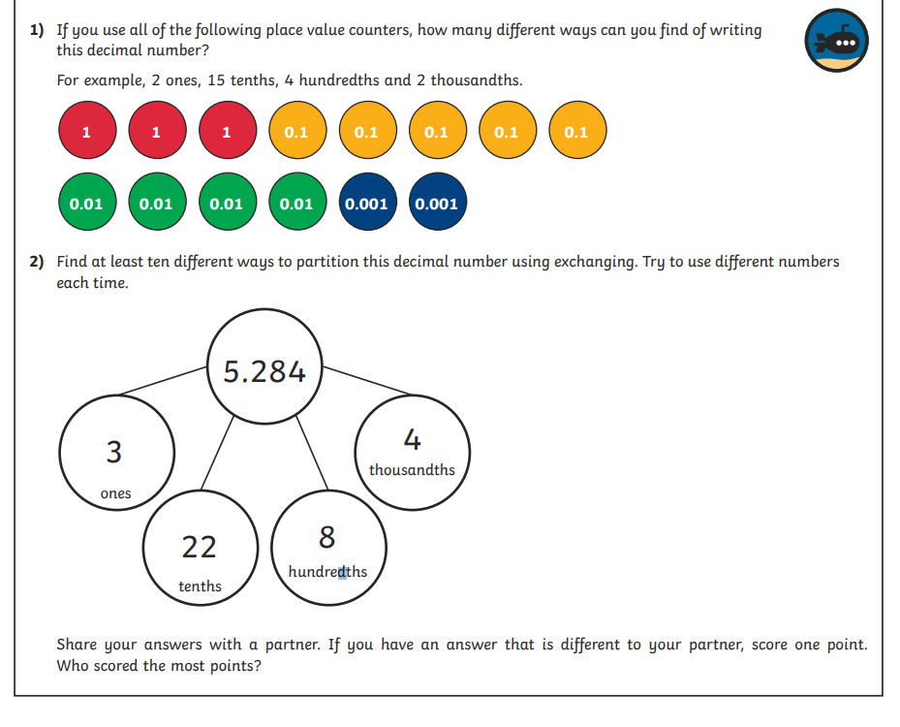
LEVEL 3 REASSONING/PROBLEM SOLVING WEDNESDAY

