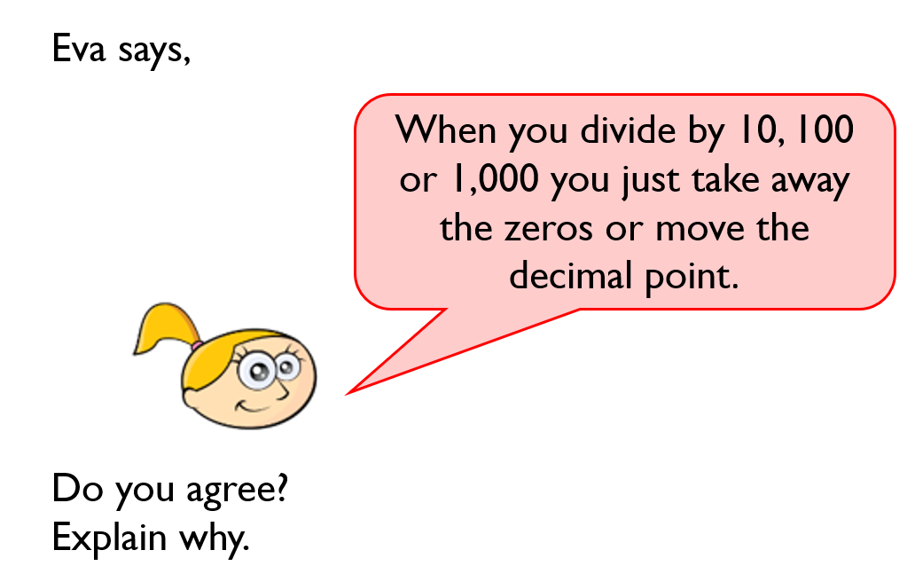
LEVEL 1 REASONING AND PROBLEM SOLVING – FRIDAY (Complete)

No, you can move the numbers around the decimal point.

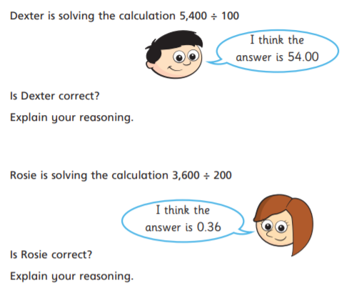

I got confused because of the decimal point though

This is correct.
Inverse 54x100 = 5,400

Incorrect
Inverse 0.36 x 100 = 36

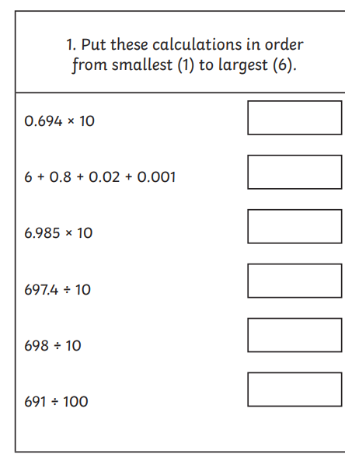
6.821

6.91

6.94

69.74

69.8

69.85

