- Each square represents 1\100.
1\100 of the whole square is shaded .
This is equivalent to 0.01 as a decimal.
B) 50\100 of the whole square is shaded
This can be simplified to 5\10
This is equivalent to 0.5

- 28\50 = 56\100
b)6\20=30\100
c)9\25=45\100
d)24\200=12\100

1)12\20=6\10=0.6
2)18\50=36\100=0.36
3)13\25=52\100=0.52
4)120\500=
5)17\20=
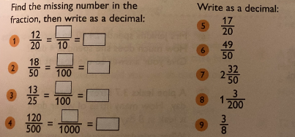
Friday Fluency Level 2


