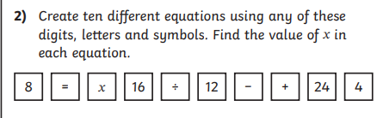
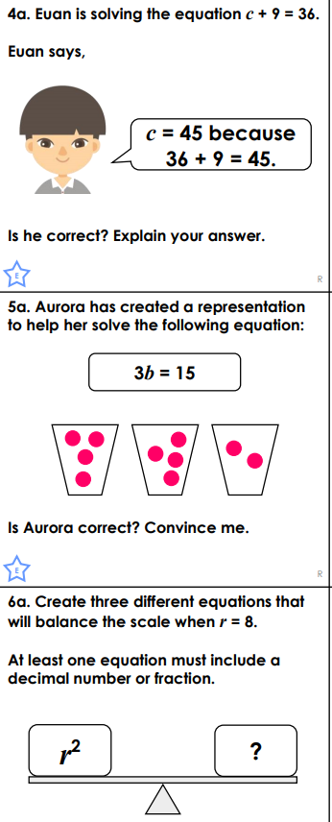
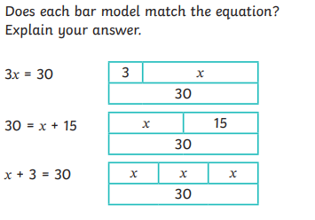
TUESDAY LEVEL 2 REASONING AND PR OBLEM SOLVING WEEK 7

