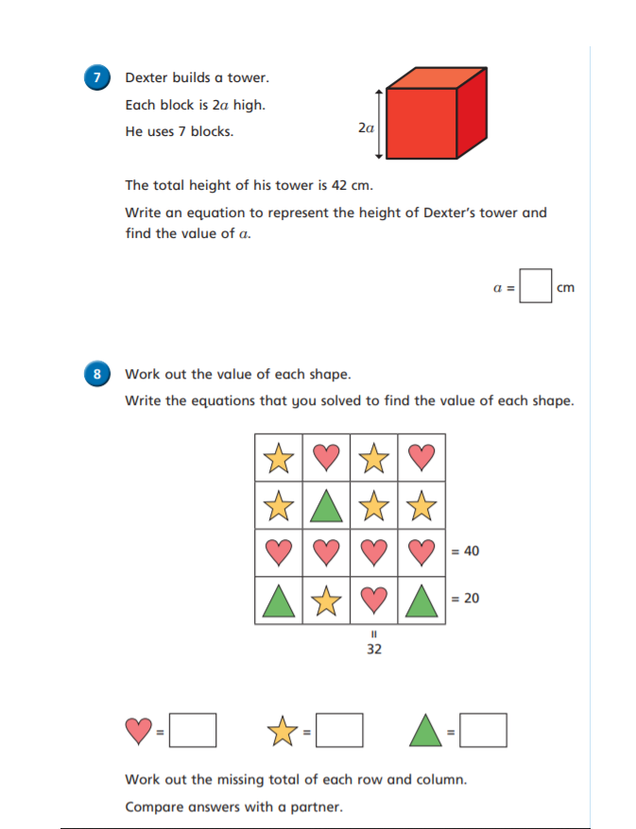
TUESDAY LEVEL 3 REASONING AND PROBLEM SOLVING WEEK 7


