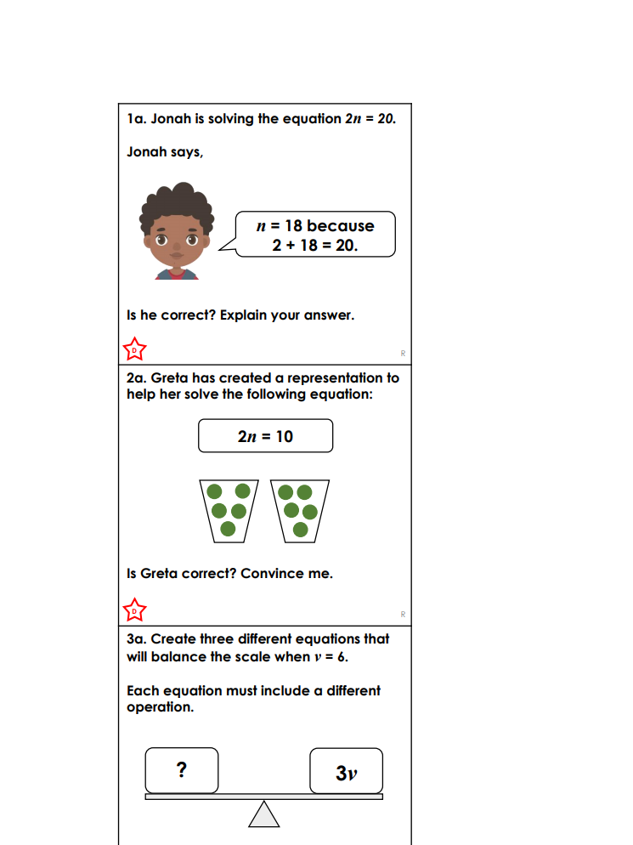
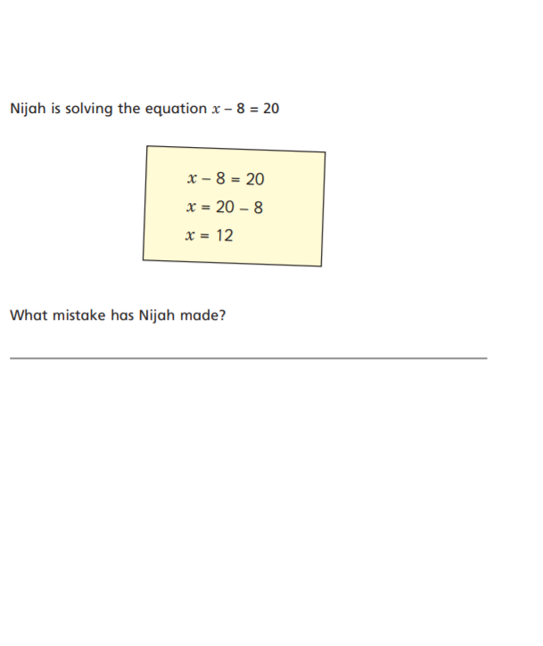
TUESDAY LEVEL 1 REASONING AND PROBLE M SOLVING WEEK 7

