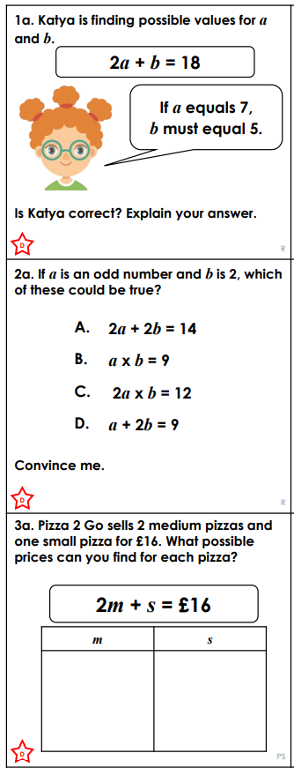
FRIDAY LEVEL 1 RPS WEEK 7

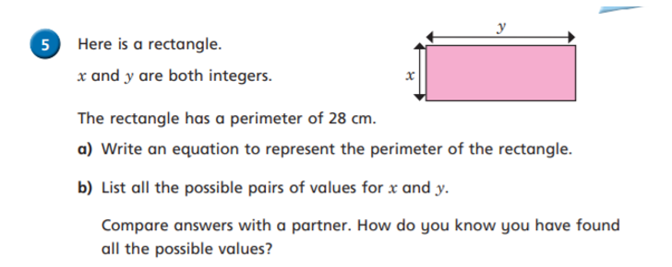
CHALENGE

