1. A because the other ones start with a six
2. 91%, 90%, 64%, 38%7%, 5%
3. Kat is correct because bar only has 10 squares and only 3 are shaded
4. A) yes only one percent is shaded
b) 10%

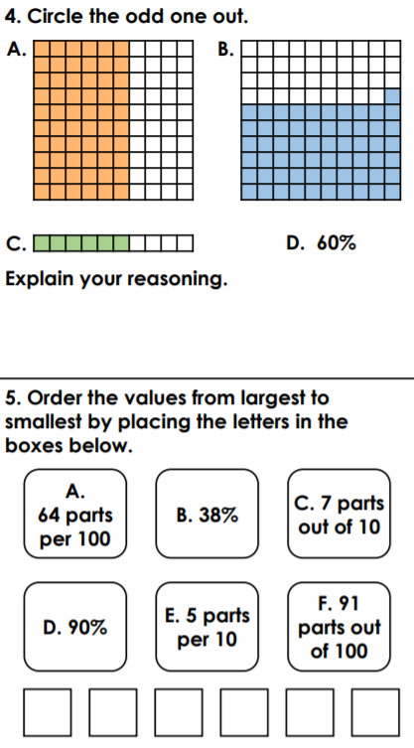
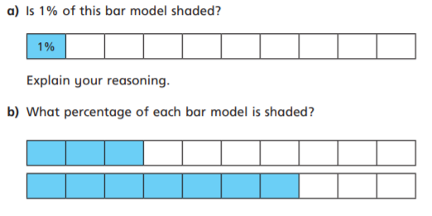
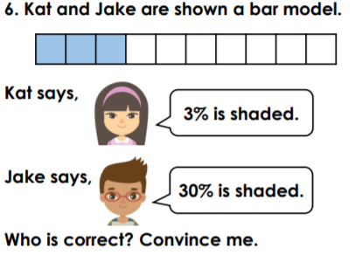
Monday – level 2 reasoning and problem solving

