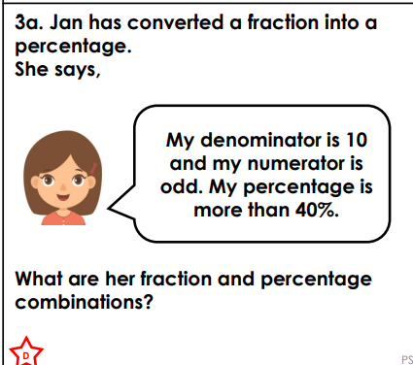
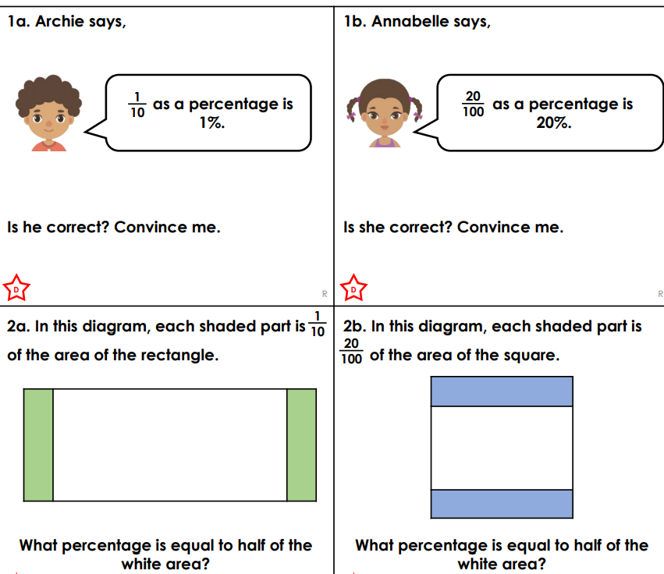
TUESDAY – LEVEL 1 REASONING AND PROBLEM SOLVING

