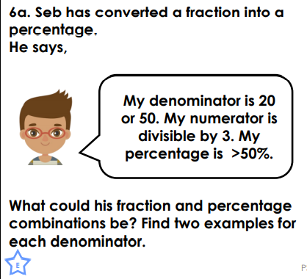
TUESDAY- LEVEL 2 REASONING AND PROBLEM SOLVING
Ron has forgot to change
Denominater.
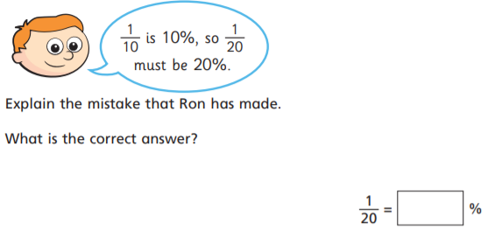

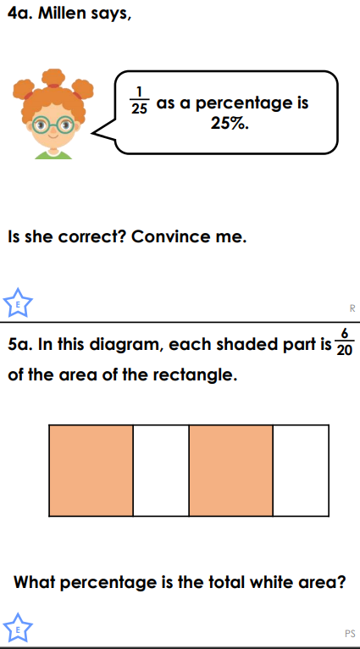
5%

She is incorect because 1\25 is 4% she forgot to
Make the denominater equivelent.

I got stuck on this one???

5
10\20=50/100=50%

25/50=50/100=50%

