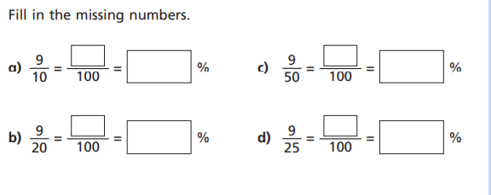
TUESDAY – LEVEL 2 FLUENCY
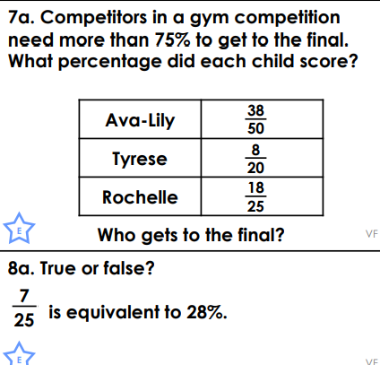
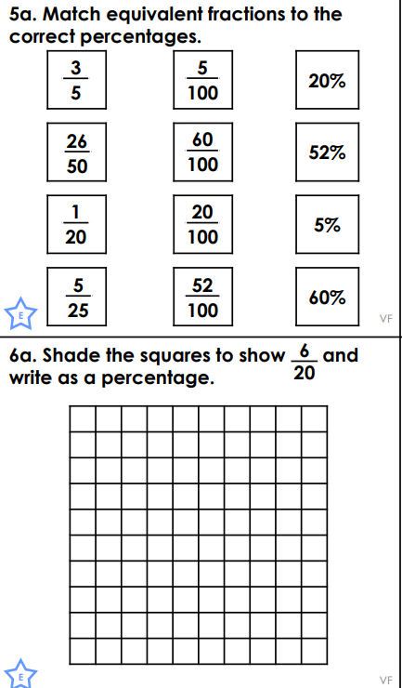
a)9\10=90/100=90% c)9/50=18\100=18%

b)9\20=45/100=45% d)9\25=36\100=36%

6a.35% 7a.ava lily gets to go to the finals beause she has 76%

True because 25 times 4 is 100 so 4 times 7 is 28 wich s 28%

