0WEDNESDAY - LEVEL 2
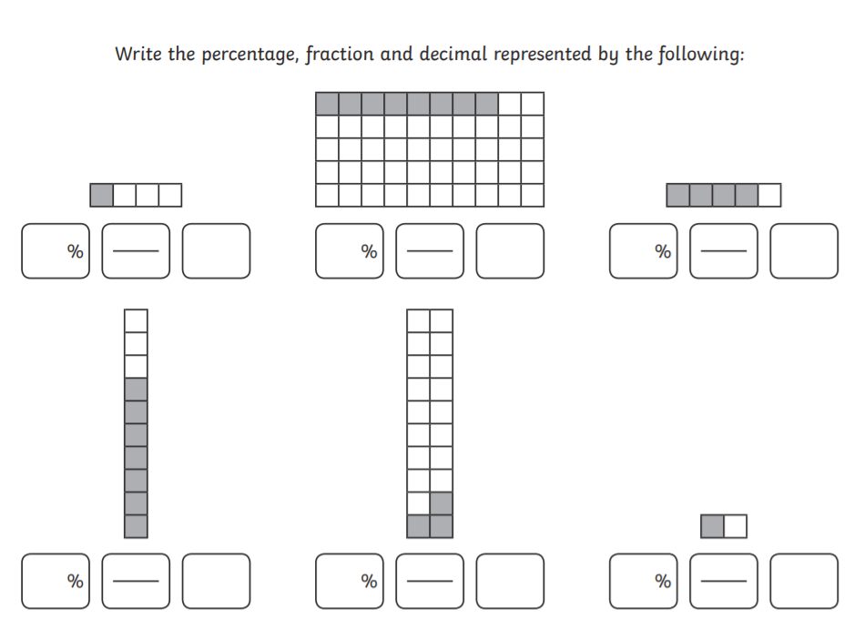
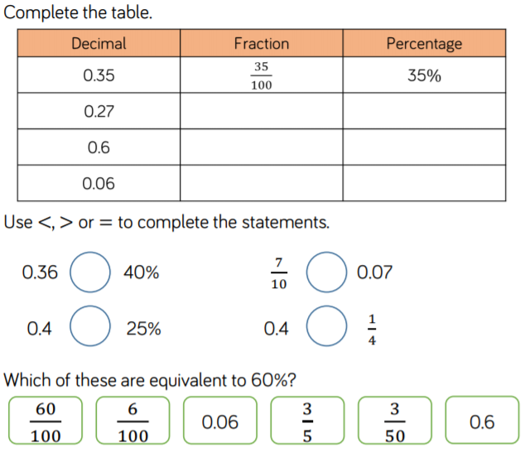
1\4 = 25/100 = 25% = 0.25 8/50 = 16/100 = 16% = 0.16 4\5 = 80\100 = 80% = 0.8

7\10 = 70\100 = 70% = 0.7 3\20 = 15/100 = 15% = 0.15 1/2 = 20/100 = 20% = 0.2

0.27 27% 27\100 0.6 6% 6\100 0.06 6\100 6%

