THURSDAY- LEVEL 2 FLUENCY
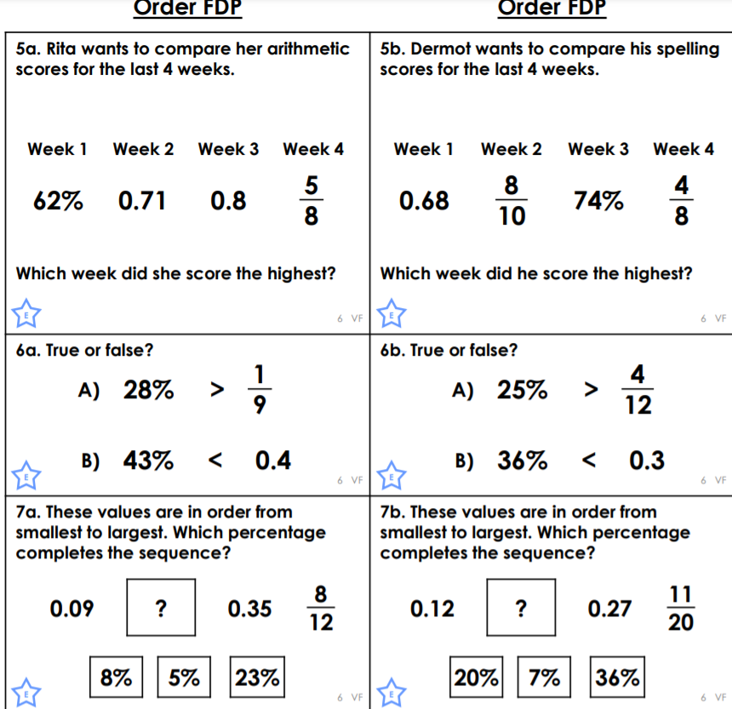
5a.0.8
5b.8\10

6a. a. true b. false
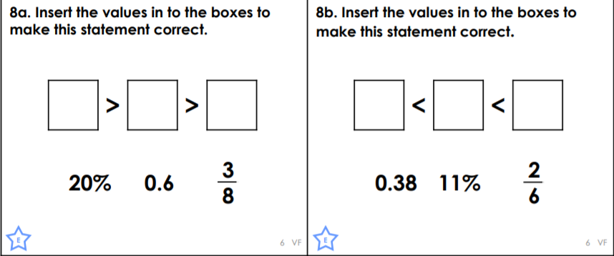
6b. a. true b. false

7a.23
7b.20

8a.20%,35%,60%,
8b.11%,16%,38%,

