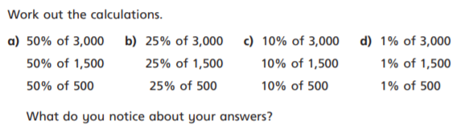
FRIDAY – LEVEL 3 FLUENCY


