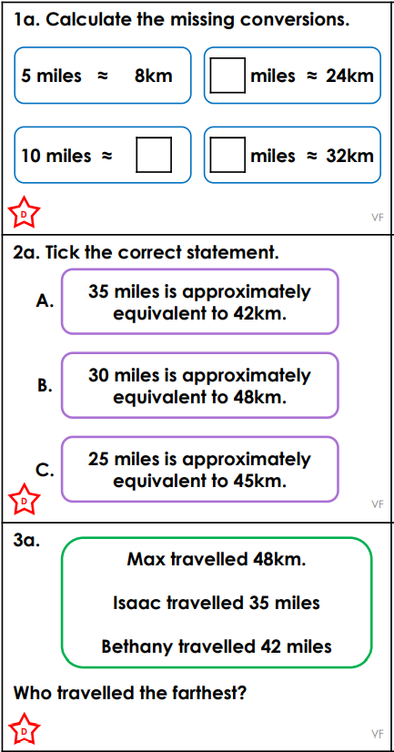
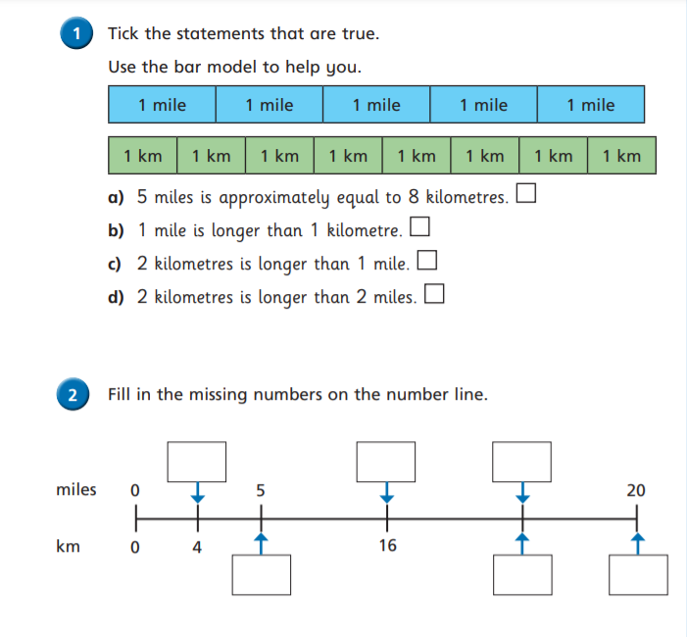
THURSDAY – LEVEL 1 FLUENCY
Helpful hints:
1 mile ≈ 1.6 km
5 miles ≈ 8km
10 miles ≈ 16km

