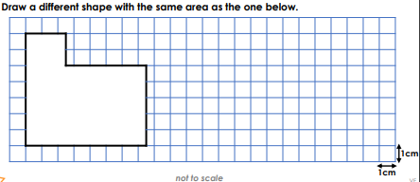
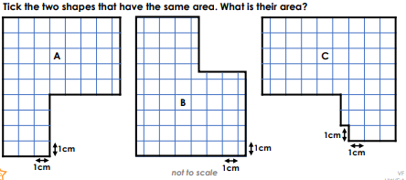
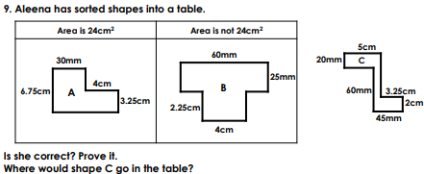

Y6 Maths Homework
SRING 2 WEEK 4 19.3.21 **
Rehearse these facts. Can you write out the fact families?
1 X 12= 12 2 X 12 = 24 3 X 12 = 36 4 X 12 = 48

7x11=7 8x11=88 9x11=99 10x11=110 11x11=121 12x11=132

