stars
grapes
tomatoes
6
3
3
9
Y6 Maths Homework
SRING 2 WEEK 5 26.3.21 **
[Grab your reader’s attention with a great quote from the document or use this space to emphasize a key point. To place this text box anywhere on the page, just drag it.]
8:4:6
4:8
8:6
6

4
8

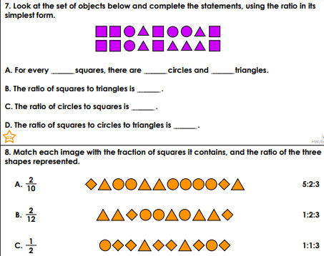
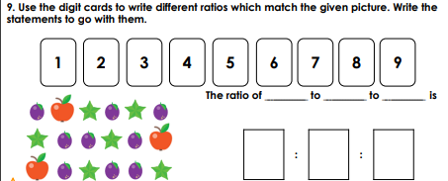

Rehearse these facts. Can you write out the fact families?
5 X 12= 60 6 X 12 = 72 7 X 12 = 84 8 X 12 = 96

7x11=7 8x11=88 9x11=99 10x11=110 11x11=121 12x11=132

