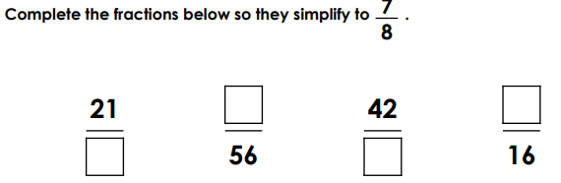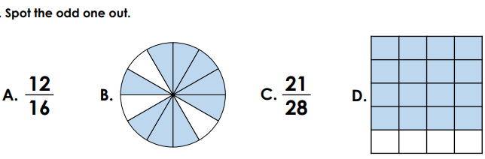
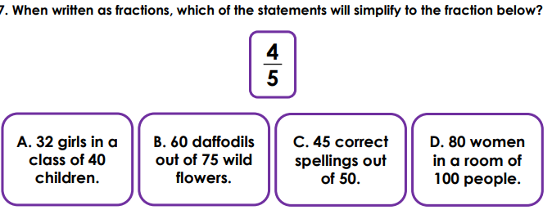
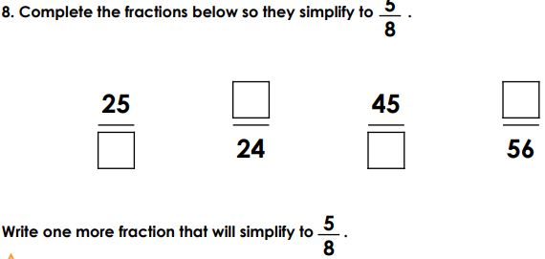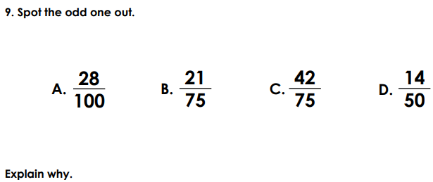

Rehearse these facts. Can you write out the fact families?
1x11=11 2x11=22 3x11=33 4x11=44 5x11=55 6x11=66
Y6 Maths Homework
Autumn 2 Week 13.11.20 *

