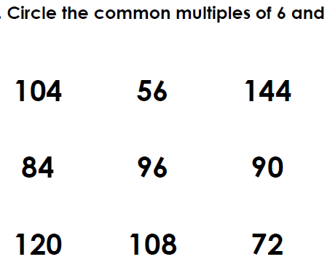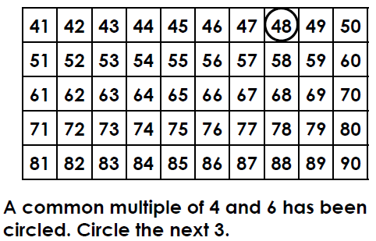

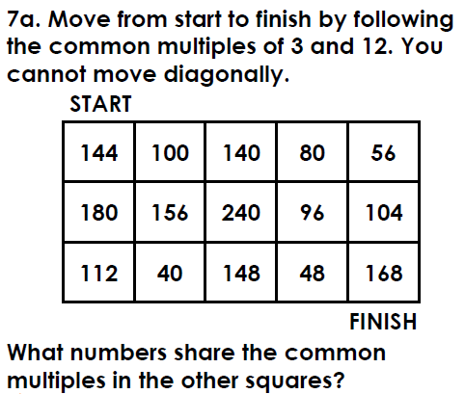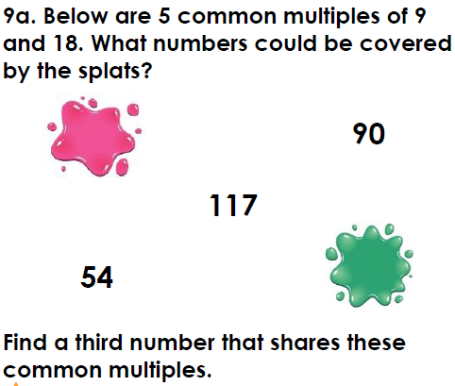
Rehearse these facts. Can you write out the fact families?
6x6=36 7x6=42 7x7=49 9x6=54 9x7=63 9x9=81
Y6 Maths Homework
Autumn 1 Week 6.11.20 **

