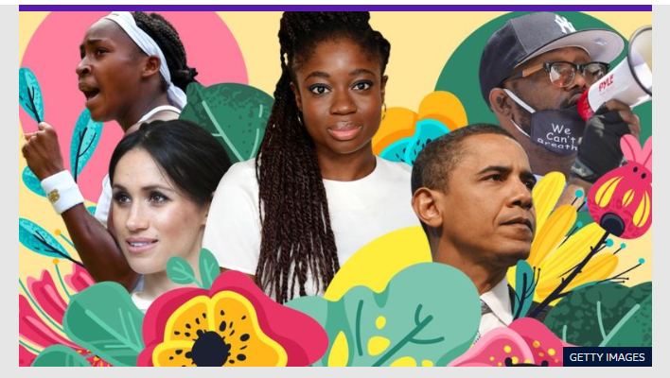
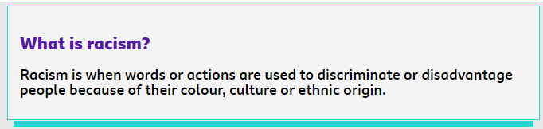
Discriminate:
Powerful:
Protest:
Violence:
Educate:
Action:
Brutality:
Potential:
Peacefully:
Solidarity:
Compassion:

