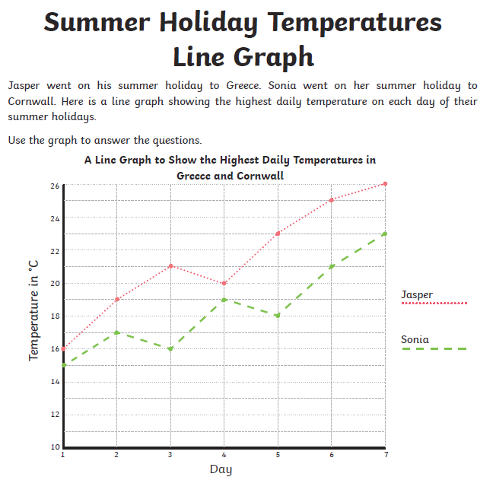

- What was the temperature on day 4 of Jasper’s holiday?
- What was the temperature on day 1 of Sonia’s holiday?
- What was the difference in temperature between Greece and Cornwall on day 3?
- How much warmer was in in Greece than Cornwall on day 7?
- On which day was the temperature of Sonia’s holiday 21◦C?
- On which day did the temperature in Greece decrease?

Write and answer 3 of your own questions about the line graph.

