Henri Matisse

Early life
Henry Matisse was born in France 1869. He was the oldest of his parents, who were rich grain merchants, sons. He studied law and got a job as a court administrator but he had to take a break because of appendicitis. Whilst in hospital, his mum gave him some art supplies and he started painting. Coming out of medical treatment he decided to become an artist for his career though his father was not pleased.
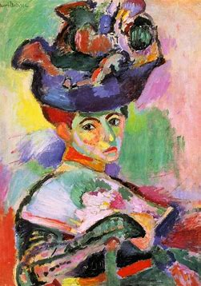
Career
Matisse started painting in a fancy traditional style. In 1896 he visited his artist friend where, he was introduced to Van Gogh’s work. Due to this experience he was determined to change his style completely. He got called “fauves” as well as other people who did the same style. This meant, wild beast.

No money left!!!
In 1902 Matisse went into debt because he spent too much money on paintings. In this period he started painting more gloomy pieces of art.

Friends and Foes
Matisse met Pablo Picasso in 1906. As they became greatest of friends they also became artist rivals.
Did you know?...
Matisse won the French Legion of honour award in 1959
Late career
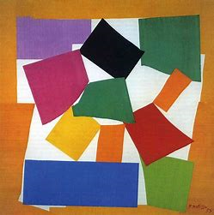
In early 1940’s Matisse had an extreme surgery which resulted him ending up in a wheelchair. At this point he was making paper collages such as the snail though he needed some help from assistants. He called his technique ‘painting with scissors.’ In 1952 there was a museum based on his work. Then in 1954 he died.
Interview:


When where you born?
I was born on the 31st of December 1869.
Where were you born?
In le Cateau-Cambesis, France.
What was your biggest achievement?
I created a new style of art using scissors!
Are you married?
For many years I was married to Amelie Noellie Parayre.
Do you have children?
Yes I had 3 children.
Do you have any famous family/friends?
I know Pablo Picasso and John Peter Russell.

