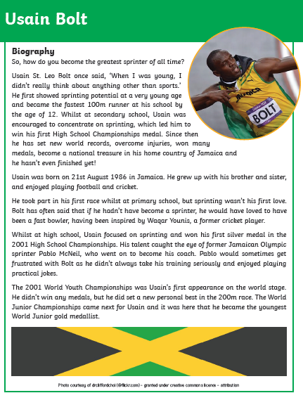
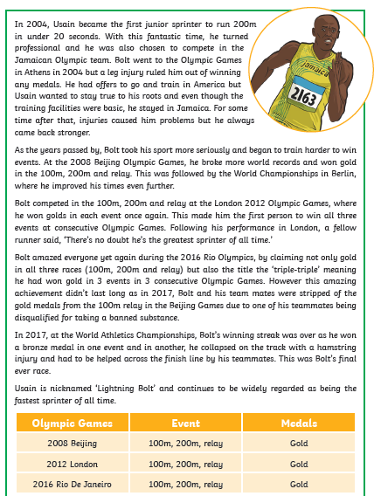
Biographies are always written in chorological (time) order and include important events from the subject’s life.
Draw a timeline and label it with key events and dates from Usain Bolt’s life

21 august 1986-was born

2001 won silver medal-high school

2008 won gold medal-in Bejjing

2012 gold medal-in London

2016 won gold medal-in Rio De Janeiro

2017 injury-won bronze medal

Here are some of the other important features of a biography. Can you find some examples of each of these?

Question or interesting opening statement to hook the reader
_So how do you become the greatest sprinter of all time
Summary of the main events of the person’s life, including:
• their main achievements Usain got loads of gold medals.
• personality
He was a really fun person and loved telling jokes
What they are remembered for
For winning a lot of races.

What about the grammar of a biography? Can you find some examples of the following grammatical features? Find a few examples for each but not all of them!
Written in the past tense:
Uses third person pronouns:

