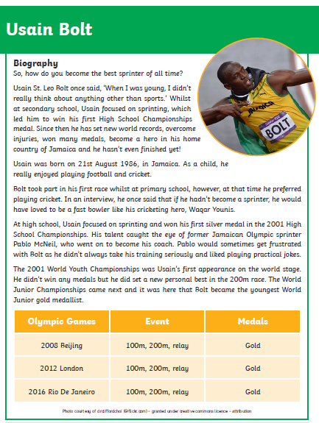
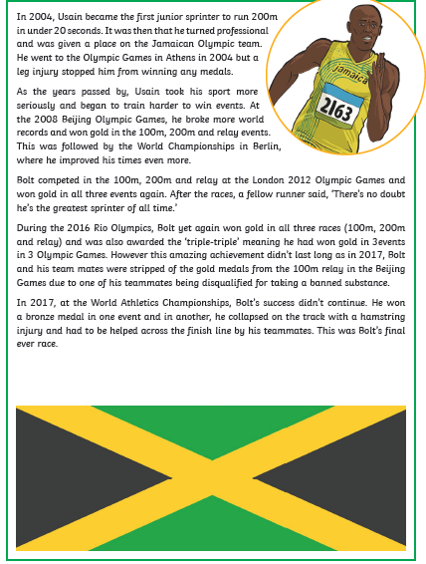
Biographies are always written in chorological (time) order and include important events from the subject’s life.
Draw a timeline and label it with key events and dates from Usain Bolt’s life

Born
First race
First medal
First world competition
First Olympic games
First gold medal
Winning the ‘triple triple’
End of racing

Here are some of the other important features of a biography. Can you find some examples of each of these?

Question or interesting opening statement to hook the reader
_______________________________________________
Summary of the main events of the person’s life, including:

• their main achievements
_______________________________________________
• personality
_______________________________________________

What about the grammar of a biography? Can you find some examples of the following grammatical features? Find a few examples for each but not all of them!
Written in the past tense:
Uses third person pronouns:

