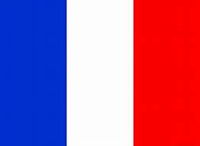
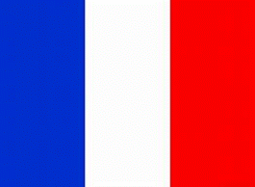
FRANCE

Want to know about France? In this text you will figure out facts about Paris, the bordering countries, the amazing food and some other interesting facts.
Paris
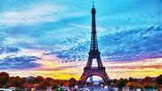
Paris is a wonderful place to go with a population of 2,175,200. Probably one of the most famous landmarks stands in Paris; the Eiffel tower. This is a steel sculpture built by Gustave Eiffel in 1889. As well as the Eiffel tower there’s the Louvre, one of the biggest museums in the world. Notre Dame, one of the most famous cathedrals in the world, is also in Paris but was badly damaged in a fire.
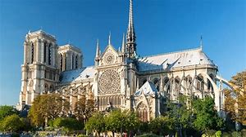
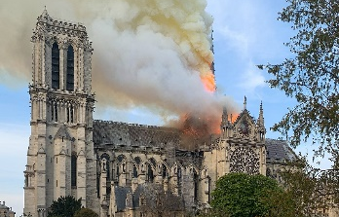


Bordering countries

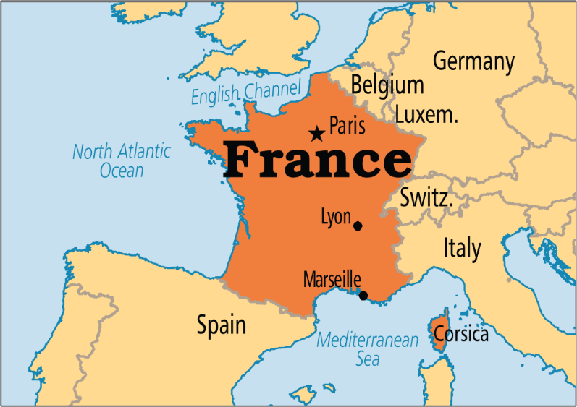
Bordering countries are countries that sit next to the country, for example England has Wales and Scotland. The bordering countries of France are Switzerland, Spain, Luxembourg, Belgium, Italy and Germany. Bodies of water bordering France are the Mediterranean sea, the English channel and Atlantic ocean.
= bordering countries
Food


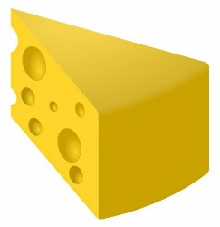

France is famous for its cheese, as it has amazingly got 350 types of cheese including BRIE. As well as that, they have a variety of wine, including champagne. Additionally, they have delicious crepes and scrumptious croissants.

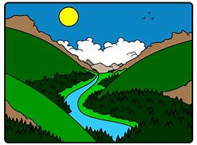

Interesting facts about France
Longest river: The Loire

Highest mountain: Mount Blanc
Population: 67.12 million

Flag colours: Red, white and blue
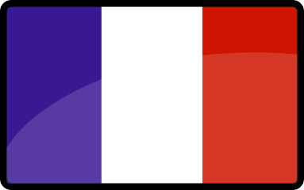
President: Emmanuel Macron

