LO: Can I solve ÷ and x problems?

- If Miss Johnson has 90 new pencils and wants to share them out equally between the 7 classes, how many would each class get? Are there any left over?

- A tram driver has £66 at the end of his shift, if all tickets were £3, how many people have ridden on his bus today?

- 4 children, Beth, Raj, Tim and Jane all collect marbles. They each have 127 marbles. How many do they have in total?

4. There are 335 children in a school and 3 houses. How many children are in each house? Are there any children left?

5. Coke cans come in packs of 12. Phil buys 24 packs. How many coke cans does he have altogether?

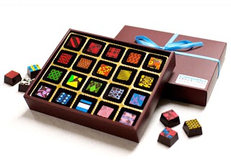
6. In a match box, there are 76 matches. Bryan buys 18 boxes. How many matches does he have in total?

7. Una buys 4 boxes of chocolates. In each box there are 658 chocolates. How many chocolates are there in total?

8. James has 59 sweets. He divides the sweets between 6 people. How many does each person get? How many sweets are remaining?

9. Steve buys 23 stamps at 45p each. How much does he spend in total?

10. Jenny is playing top trumps – there are 143 cards in a pack. She deals the cards to 4 players. How many cards does each player get? How many are spare?

