Number boundary | Number | 1% | 10% | 20% | 25% | 50% | 100%
1-100 | 38 | 0.38 | 3.8 | 7.6 | 9.5 | 19 | 38
1-100
1-100
100-1000
100-1000
100-1000
1000-10,000
1000-
10,000
1000- 10,000
What patterns can you notice? How are the different percentages related? What shortcuts can you take?
Medium Spice
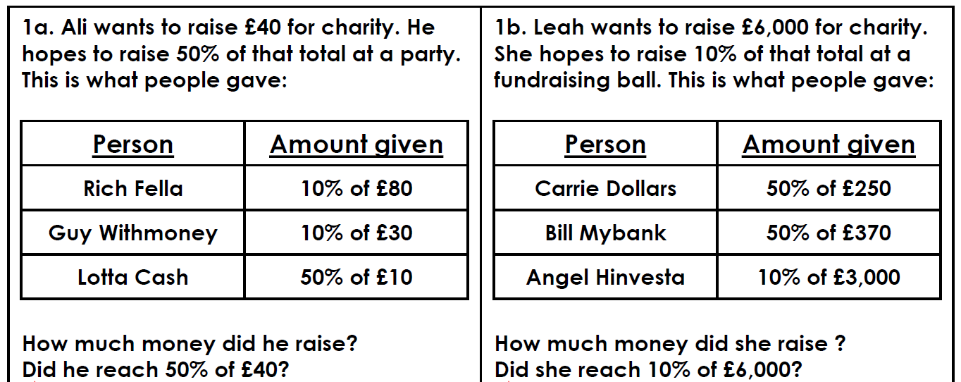
Hot Spice
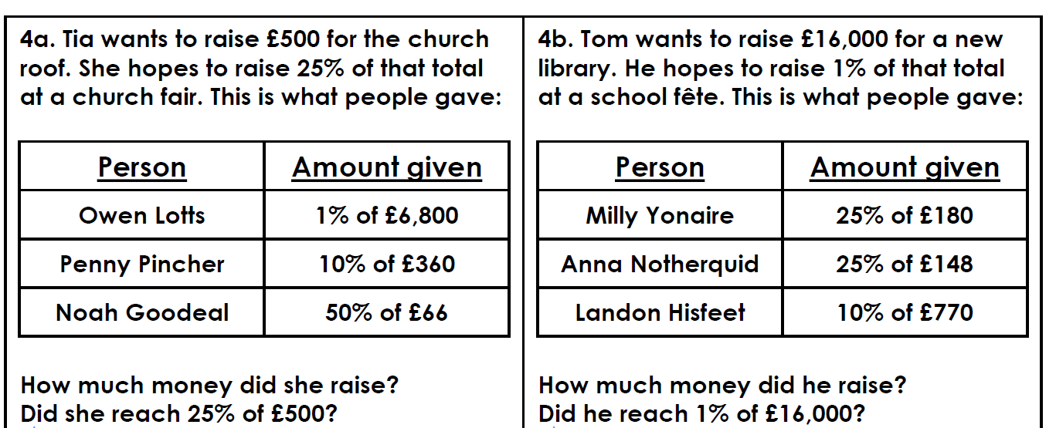
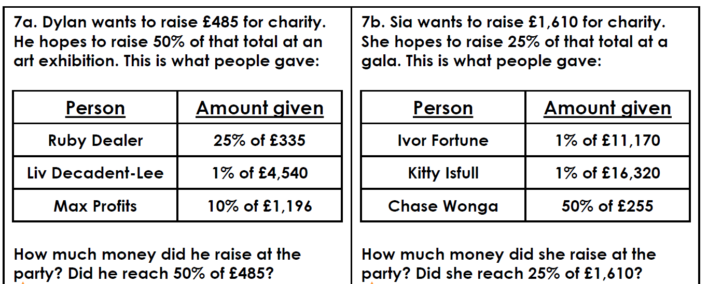
Super Super Spicyyyy!

