Forward roll
Ch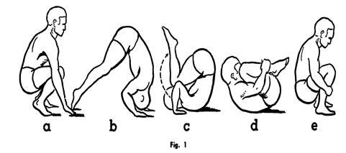
Chin tucked in
Top of back touches floor (NOT HEAD!)
Challenge: Can you stand up at the end?
Backward roll
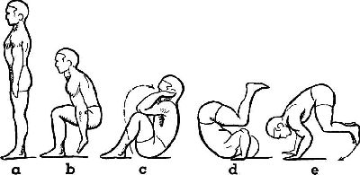
Keep chin tucked in
Use arms to push for power
Keep body weight central, in tucked position
Handstand
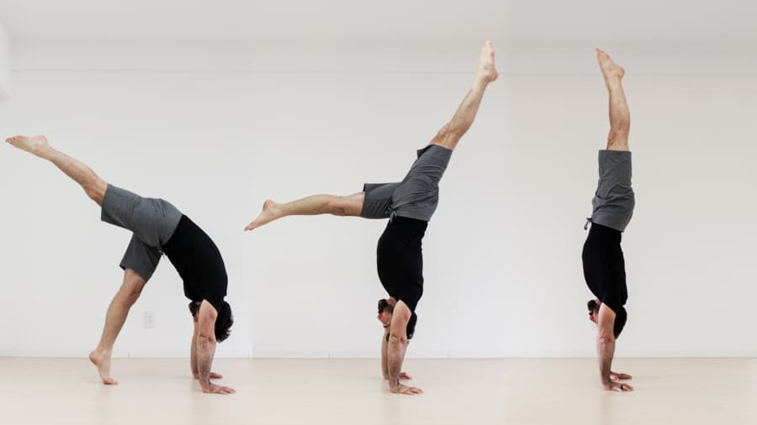
This must be supported your partner!

Lunge forward.
Kick up to handstand pose.
Arms, back and legs straight. Point toes to ceiling.
Handstand
This must be supported your partner!

Lunge forward.
Kick up to handstand pose.
Arms, back and legs straight. Point toes to ceiling.
Forward or backward roll on bench.
If your partner is not confident, please support/ be ready to catch them!

Challenge: Can you stand up at the end of the roll and perform a gymnastics jump?

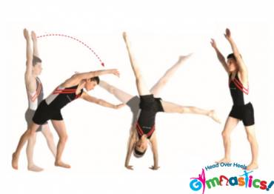
Cartwheels over the bench
Keep arms straight throughout move

Make an upside down star (legs straight!)

Land facing the way you came

Forward or backward roll on bench.
If your partner is not confident, please support/ be ready to catch them!

Challenge: Can you stand up at the end of the roll and perform a gymnastics jump?

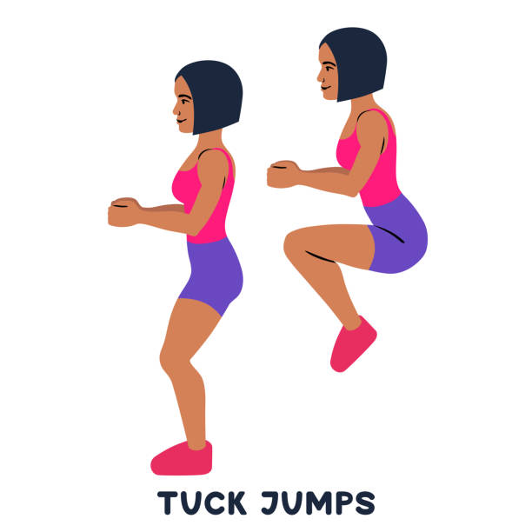
How many tuck jumps can you do in a minute?
Can you beat your partner?
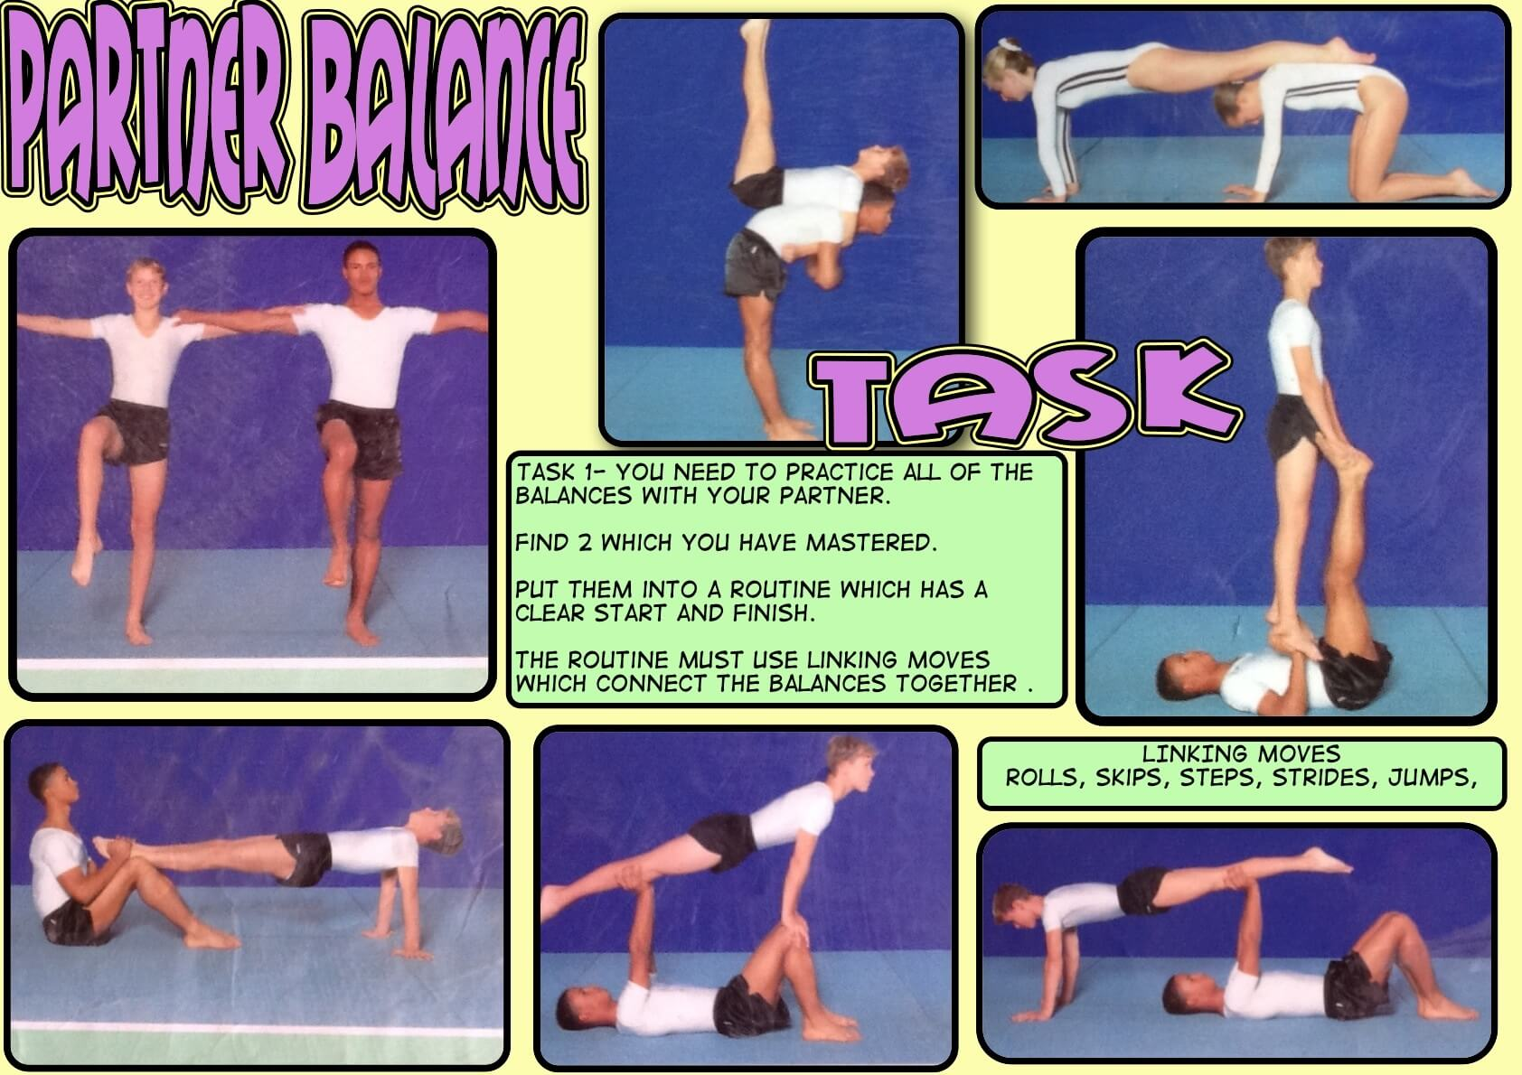
Notice their straight backs or legs in the balances!
Choose a balance (quickly!) and try to hold for as long as you can!
How long can you hold back support for? Hips to the sky, squeeze your bum (and hold!)
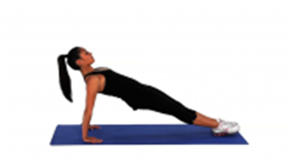
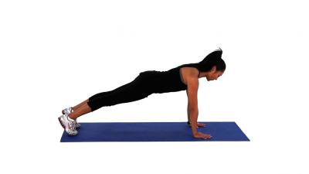
How long can you hold front support for? Keep back straight, squeeze your tummy muscles (and hold!)

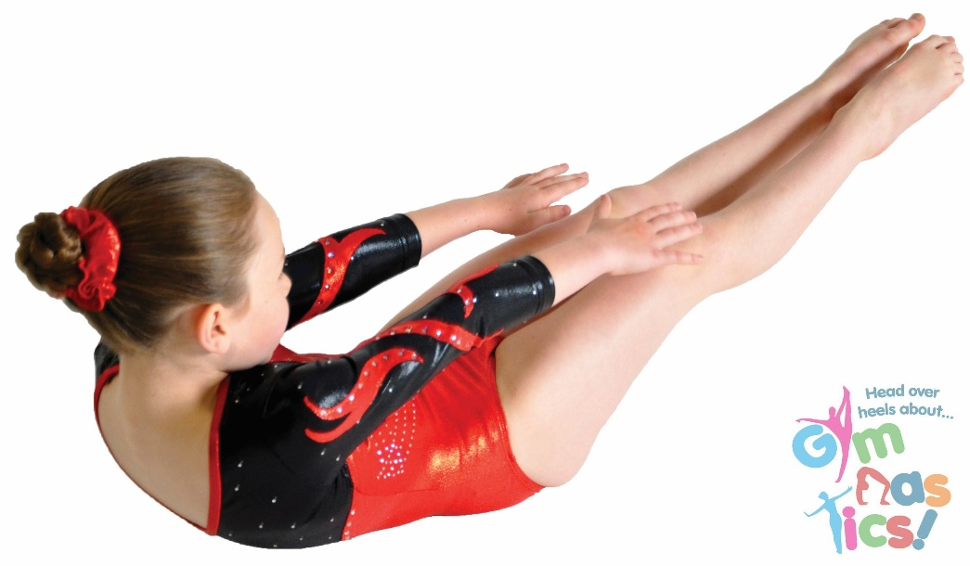
How long can you hold the dish shape for? Squeeze your tummy muscles, raise shoulders of the floor, keep feet about a 30cm ruler length off the floor.
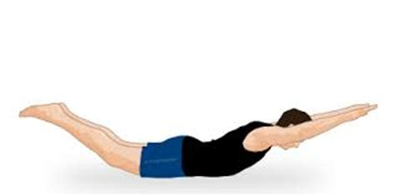
How long can you hold the arch shape for? Lift legs and arms off the floor, keep both straight, and hold!

