Task 2: Draw pictures to illustrate a guide to looking after beach habitats. The first one is done as an example
Take your litter home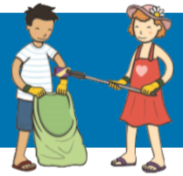
What Could We Do to Help Look after Our Beaches?
Take photos of plants instead of picking them
Leave the shells at the beach

