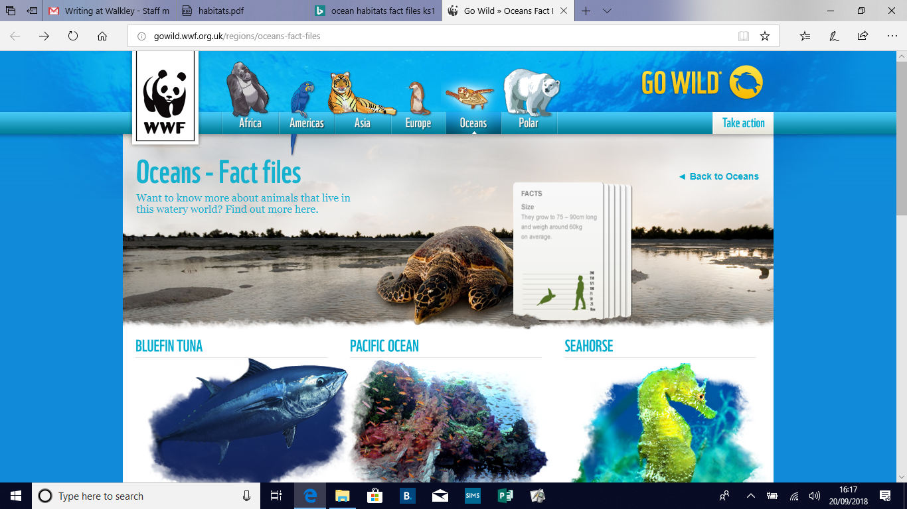
Task 3: Use an iPad and the QR code to research your own ocean animal.
Choose one of the animals and then write facts about it. Don’t forget to draw an illustration of your chosen animal.
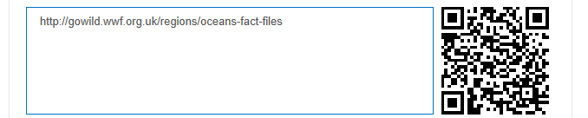
Name of ocean animal___________________________
Best feature: ________________________________________________________________________________________________
Size: ___________________________________________

Favourite food: ________________________________________________________________________________________________
Interesting fact: ________________________________________________________________________________________________
________________________________________________
What else can you find out?
________________________________________________________________________________________________________________________________________________________________________________________________
Illustration:

