Day Four Task
The story ends with “Amazingly, the next day, there I was in the local paper. A hero.”
Your task is to design and write the newspaper article in the local paper.
You article could include:
- Quotes from the characters- The boy, the girl, The American Ambassador, The mum..
- A picture. This could be of the characters, the events or maybe the house?
- An attention grabbing headline
- An introduction, middle section telling the story, and conclusion
- Other things that may be on a newspaper- think advertising, short side stories, page number… little details.

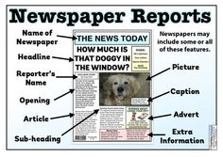
Scroll down for a template you could use- by all means print this page or use it as a guide to design your report.



