Day Five Task
One crucial part of the story is missing… How did the girl even get into the old house??
Your job today is to design a comic book strip on how the girl was kidnapped, finishing with being stuck in the room in the house.
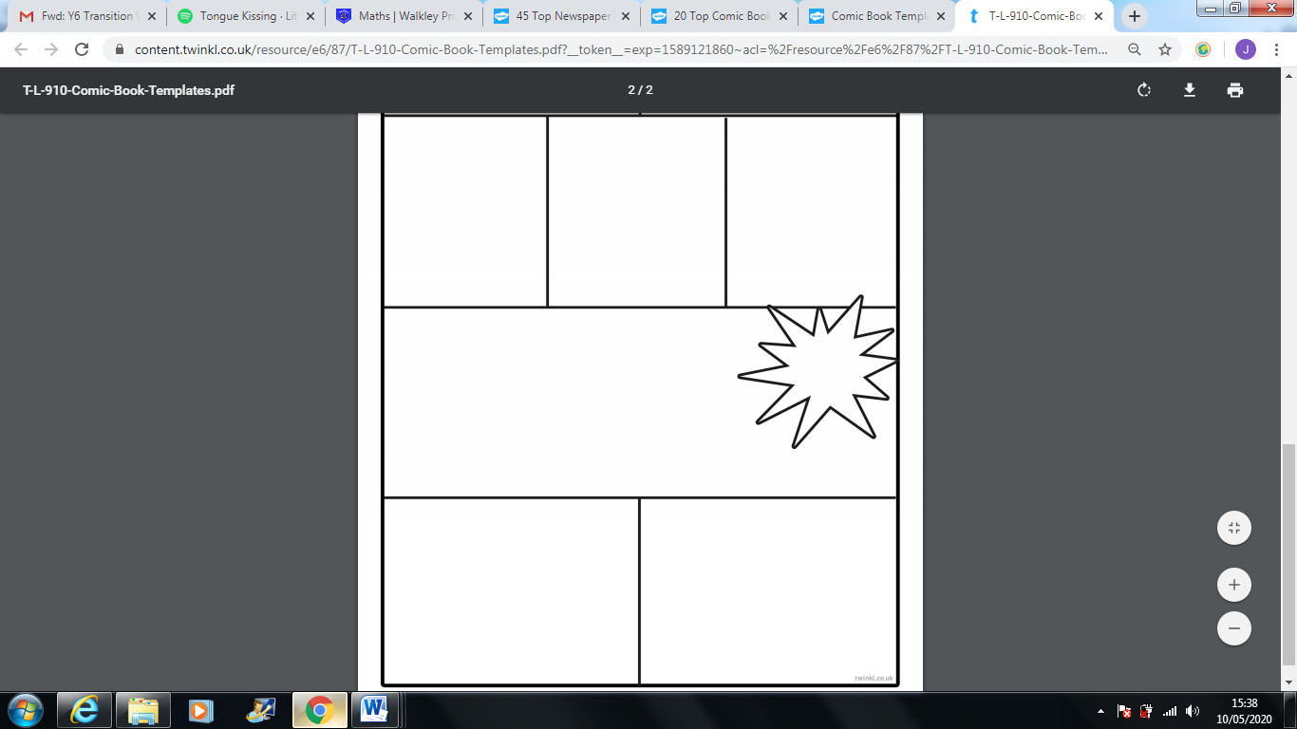
I have attached a template of a comic book strip to help you get started!

