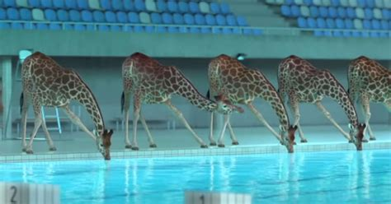
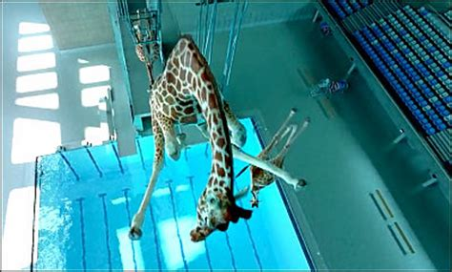
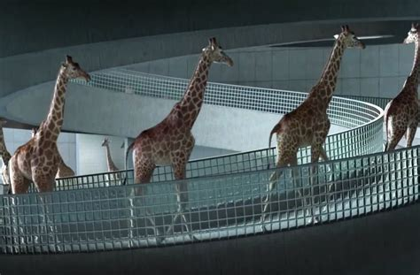
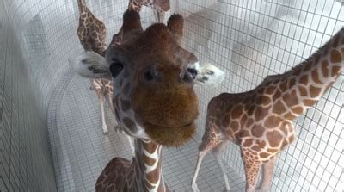
Who

What

Where

Why

When
How did the Giraffes get caught/found out?
What did the Giraffes say?
Quotes from the event.
Who said what?

V
P
O
C
What happened?
Newspaper report Headline-
Giraffes caught on CCTV diving in Sheffield swimming pool!

