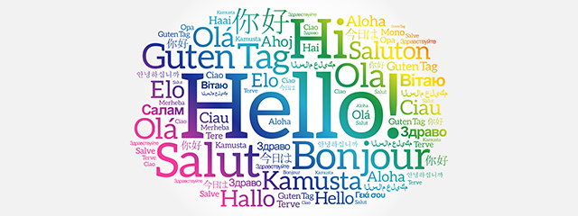.
Punctuation
Openers
Connectives
Vocabulary
Overall, I think it would be better/worse
It would be bad because
It would be good because
What would the world be like if we all spoke the same language?

